Portfolio Management Dashboard - Detailed Development Documentation
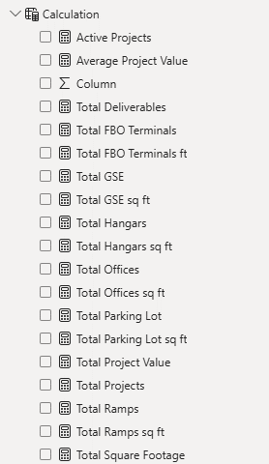
This document explains the complete development process for the Portfolio Management Dashboard built in Power BI Desktop using the Portfolio table.
SECTION 1 – PROJECT OVERVIEW
Purpose:
- Executive Portfolio Reporting
- Regional Analysis
- Deliverable Tracking
- Square Footage Analysis
- Multi-Year Timeline Tracking
SECTION 2 – DATA SOURCE
Source: Excel Workbook
Table Name: Portfolio
Steps:
1. Open Power BI Desktop.
2. Click Get Data > Excel Workbook.
3. Select source file.
4. Load Portfolio table.
5. Open Power Query.
6. Verify text, numeric and date data types.
7. Click Close & Apply.
SECTION 3 – POWER QUERY TRANSFORMATIONS
Custom Column 1: Project Start Date
Purpose:
Create a single start date from available milestone dates.
Custom Column 2: Substantial Completion Date
Purpose:
Create a single completion date from available completion milestones.
Business Benefit:
Allows timeline and Gantt reporting.
SECTION 4 – CALCULATION TABLE
Table Name: Calculation
Measures:
- Active Projects
- Average Project Value
- Total Deliverables
- Total FBO Terminals
- Total FBO Terminals ft
- Total GSE
- Total GSE sq ft
- Total Hangars
- Total Hangars sq ft
- Total Offices
- Total Offices sq ft
- Total Parking Lot
- Total Parking Lot sq ft
- Total Project Value
- Total Projects
- Total Ramps
- Total Ramps sq ft
- Total Square Footage
Purpose:
Centralized measure management and easier maintenance.

SECTION 5 – PAGE 1
Title: Executive Portfolio Summary Dashboard
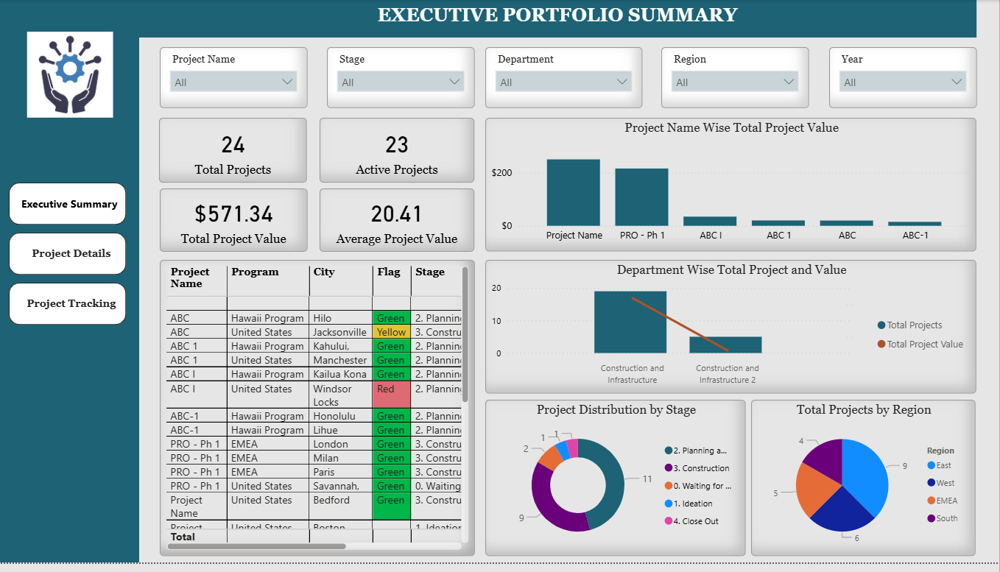
Filters:
Project Name
Stage
Department
Region
Year
KPI Cards:
1. Total Projects
2. Active Projects
3. Total Project Value
4. Average Project Value
Visuals:
1. Project Name Wise Total Project Value (Bar Chart)
2. Department Wise Total Project and Value (Bar Chart)
3. Project Distribution by Stage (Donut Chart)
4. Total Projects by Region (Pie Chart)
5. Project Details Table
Purpose:
Provide executive-level portfolio overview.
SECTION 6 – PAGE 2
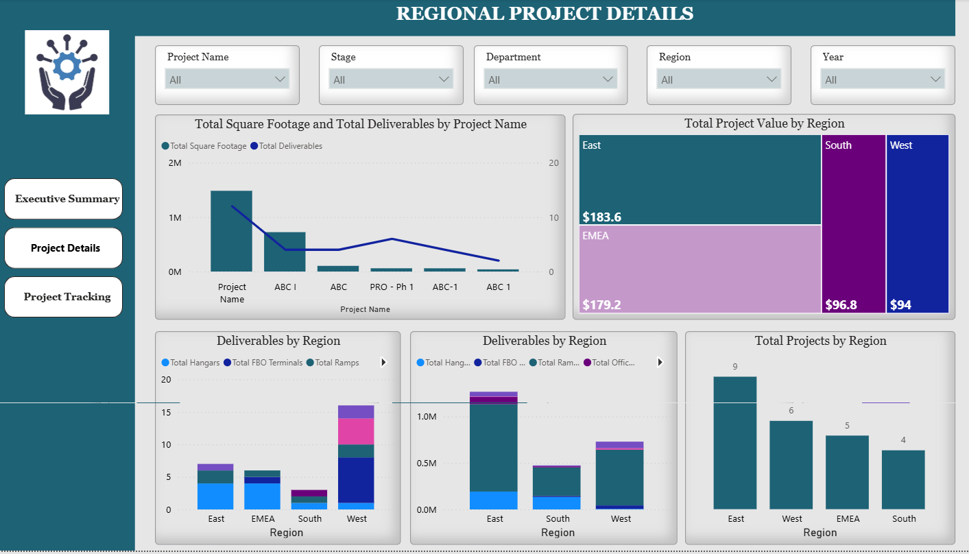
Title: Regional Project Details Dashboard
Filters:
Project Name
Stage
Department
Region
Year
Visuals:
1. Total Square Footage and Total Deliverables by Project Name
2. Total Project Value by Region (Treemap)
3. Deliverables by Region (Left)
4. Deliverables by Region (Right)
5. Total Projects by Region
Purpose:
Analyze regional performance, deliverables and infrastructure footprint.
SECTION 7 – PAGE 3
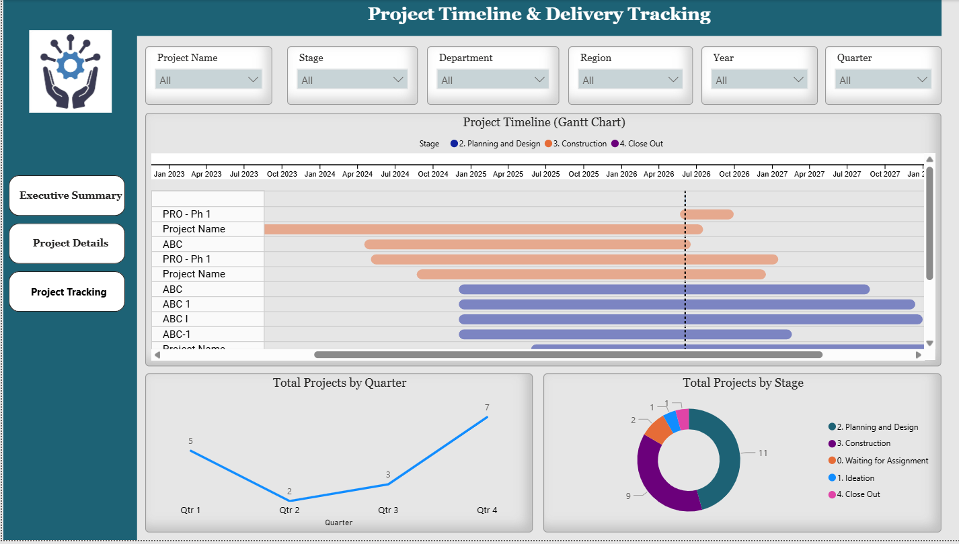

Title: Project Timeline & Delivery Tracking Dashboard
Filters:
Project Name
Stage
Department
Region
Year
Quarter
Visuals:
1. Project Timeline (Gantt Chart)
2. Total Projects by Quarter (Line Chart)
3. Total Projects by Stage (Donut Chart)
Purpose:
Track project schedules, milestones, start dates and completion dates.
Timeline Features:
- Multi-Year Projects
- Start Date Tracking
- Completion Date Tracking
- Quarter Analysis
- Executive Monitoring
SECTION 8 – DASHBOARD INTERACTIVITY
Features:
- Cross Filtering
- Cross Highlighting
- Dynamic Slicers
- Interactive Analysis
SECTION 9 – MAINTENANCE GUIDE
1. Update the Excel file.
2. Open PBIX.
3. Click Refresh.
4. Validate metrics.
5. Save PBIX.
6. Publish the updated version if required.
SECTION 10 – CONCLUSION
The dashboard provides a complete executive portfolio management solution with portfolio monitoring, regional analysis, deliverable tracking, square footage analysis and timeline reporting.

